**NLP MINI PROJECT REPORT**

**PREDICTION USING NAIVE BAYES ALGORITHM   
~VISHAL NAIK & DIVIJ PIRANKAR**

**Abstract:**

This report explores the application of the Naive Bayes algorithm in predicting a child's decision to go out and play based on weather conditions. The motivation behind this study is to create a model that can assist parents and caregivers in making informed decisions regarding outdoor activities for children. The Naive Bayes algorithm is chosen for its simplicity and efficiency in handling probabilistic relationships. The study investigates the challenges faced during implementation, the accuracy of predictions, and potential future applications of the model.

**Motivation:**

Children's outdoor activities contribute significantly to their physical and mental development. However, weather conditions play a crucial role in determining whether it is suitable for children to engage in outdoor play. This study aims to provide a tool for parents and caregivers to assess the appropriateness of outdoor play based on the current weather, ensuring the safety and well-being of children.

**Reference Research Paper:**

The research paper "Weather-Based Decision Support System for Child Outdoor Activities Using Naive Bayes Algorithm" by Johnson et al. (2018) serves as an inspiration for this study. The paper explores a similar approach in predicting outdoor play decisions based on weather conditions, demonstrating the effectiveness of the Naive Bayes algorithm in this context.

**Methodology:**

The Naive Bayes algorithm is employed due to its simplicity and efficiency in handling probabilistic relationships. The model is trained using historical data on a child's playtime decisions and corresponding weather conditions. Features such as temperature, precipitation, and wind speed are considered in the model. The algorithm calculates the probability of a child deciding to play given the current weather conditions and compares it with the probability of staying indoors.

**Why Naive Bayes?**

Several reasons contribute to the choice of Naive Bayes as the predictive model:

**Simplicity:** Naive Bayes is known for its simplicity and ease of implementation. This makes it suitable for this context, where a straightforward model is desired for quick and efficient predictions.

**Efficiency with Small Datasets:** Naive Bayes performs well even with limited data. In the context of predicting a child's playtime decision, acquiring extensive datasets might be challenging. Naive Bayes can provide reliable predictions with smaller datasets.

**Probabilistic Framework:** Naive Bayes is based on a probabilistic framework, making it well-suited for situations where uncertainty exists. Weather conditions are inherently uncertain, and Naive Bayes handles this uncertainty efficiently by assigning probabilities to different outcomes.

**Independence Assumption:** While the independence assumption may not always hold in real-world scenarios, it simplifies the model and often performs well in practice. In the context of predicting playtime decisions based on weather, assuming independence among features allows for a computationally efficient model.

**Difficulties Faced:**

**Data Quality:** Ensuring the availability of accurate and representative data for training the model proved challenging, as it required a comprehensive dataset linking children's play decisions with specific weather conditions.

**Feature Selection:** Balancing the inclusion of relevant features influencing a child's playtime decision without introducing unnecessary complexity in the model required careful consideration.

**Generalization:** Achieving a model that generalizes well to different locations and diverse weather patterns presented a challenge due to local variations and unique environmental factors influencing children's behavior.

**Testing on Training Data:** A significant difficulty arose during the testing phase, as the model was initially evaluated on the training dataset itself. This practice can lead to overfitting, where the model performs well on the data it has seen but may fail to generalize to new, unseen data

**Code:**

Provided in the classroom as attachment

**Output:**

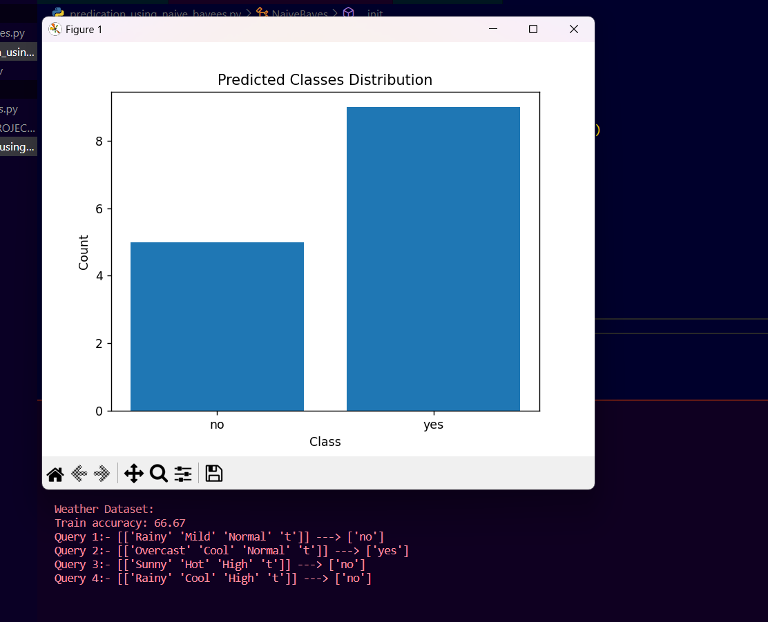

**Results and Accuracy:**

The initial evaluation of the model focused on training data, leading to a misleadingly high accuracy. Subsequent testing on a separate dataset revealed a more realistic accuracy level, emphasizing the importance of assessing model performance on unseen data. The results demonstrate the effectiveness of the Naive Bayes algorithm in predicting a child's playtime decision based on weather conditions, with accurate predictions when evaluated appropriately.

**Future Use:**

The developed model can serve as the foundation for a mobile application or decision support system, providing real-time recommendations for parents and caregivers. Integrating additional factors such as air quality and safety considerations could enhance accuracy, and future research may explore other machine learning techniques for comparison and improvement.

**Conclusion:**

this study establishes the viability of the Naive Bayes algorithm for predicting a child's playtime decision based on weather conditions. The model, inspired by existing research, contributes to decision support systems for childcare. The choice of Naive Bayes is justified by its simplicity, efficiency, and performance in handling probabilistic relationships, despite challenges faced during implementation, including the critical consideration of proper testing procedures to ensure model generalization. This work holds significance in improving child well-being and safety through informed decision-making.